***SESSION BASED AUTHENTICATION***

**What is Authentication?**

* It is processes which can be interact between “PERSON and COMPUTER”.
* For Example: We take “GMAIL ACCOUNT”
* If user who wish to access their account. They type Their “Uname and Password” and get it into their account otherwise we can’t.
* So here the Security Authentication is powerful.
* Only users can access.
* Verify the user through a code as a password.

**Types of Authentication:**

1. Session Based Authentication.

2. Token Based Authentication.

**What is Session Based Authentication?**

* To set the Uname and Password for the Client side. We have two methods to Authenticate.

***1. Basic Uname and Password.***

***2. Session Based Uname and Password.***

* The Time during the client will login to the server through “COOKIES”.
* It can be able enable and control session Authentication.
* If the Uname and Password Authentication sends the client name and Unencrypted Password and sent each request to the server.

***GMAIL***

**Why we need Session Based Authentication in Gmail?**

This when your app confirms a person's identity after checking previously. With Gmail Login, your app asks a person to re-enter their Gmail password at any time. You can use this to prevent cases where a user leaves a device logged in or where a third party “***hijacks”*** someone's session with your app.

Apps should build their own mechanisms to switch between different Gmail user accounts using log out functions and should not rely upon re-authentication for this.

***IMPLEMENTATION OF MY GMAIL ACCOUNT:***

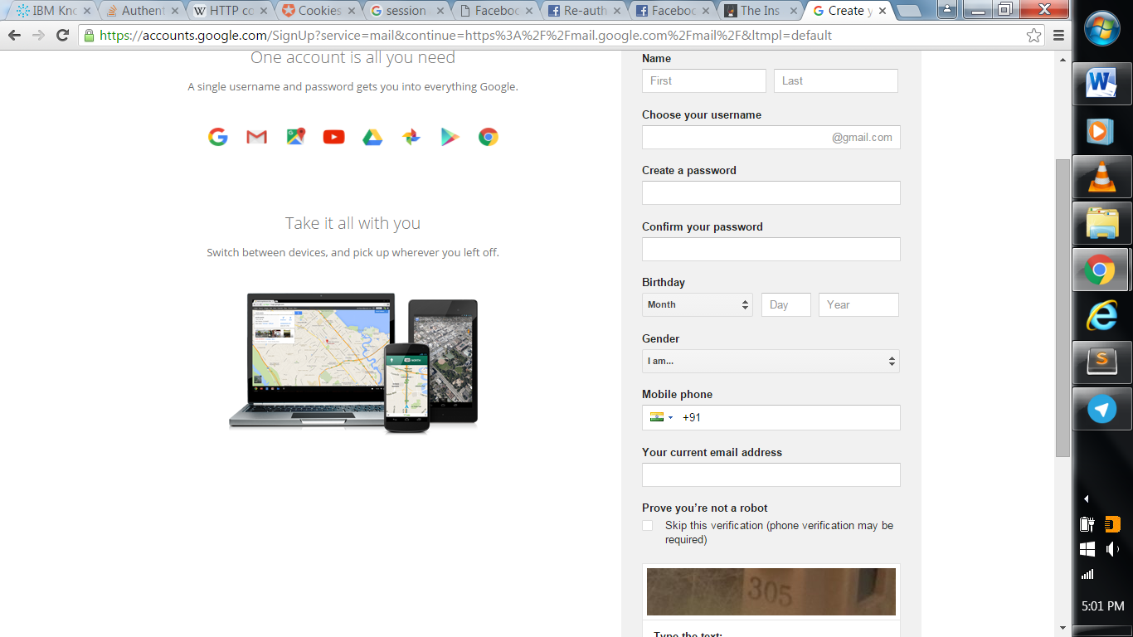

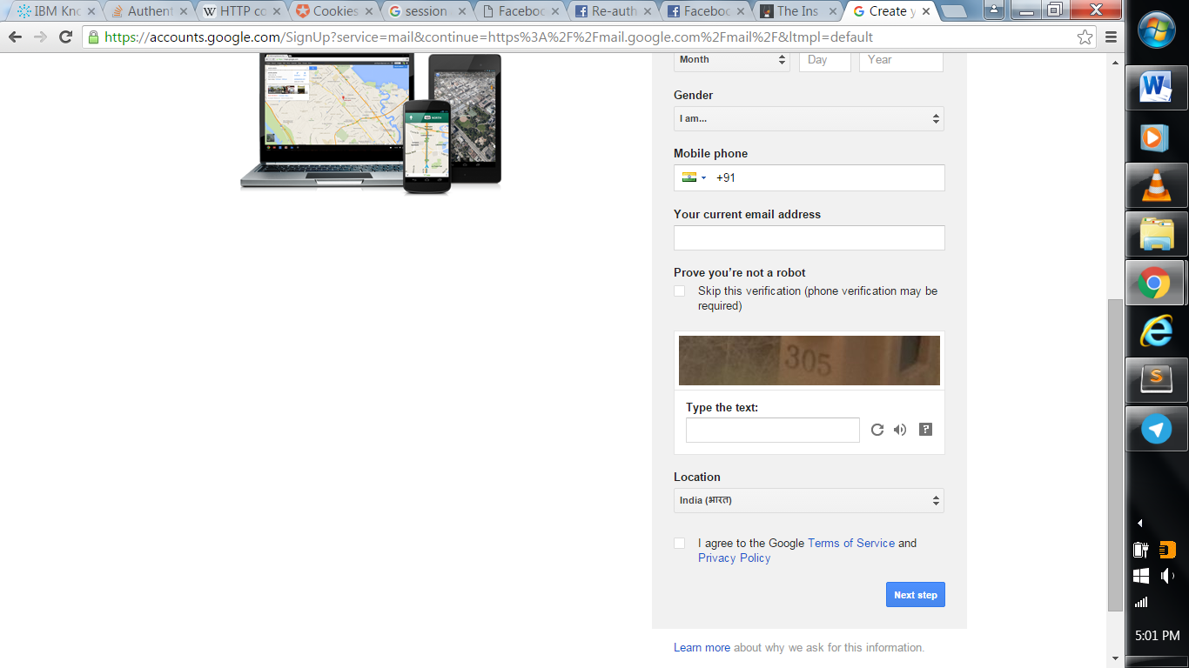

This is my First page of my Gmail creation. We have fill everything which we given in the screen.After that we have Click next Button and get into another page.

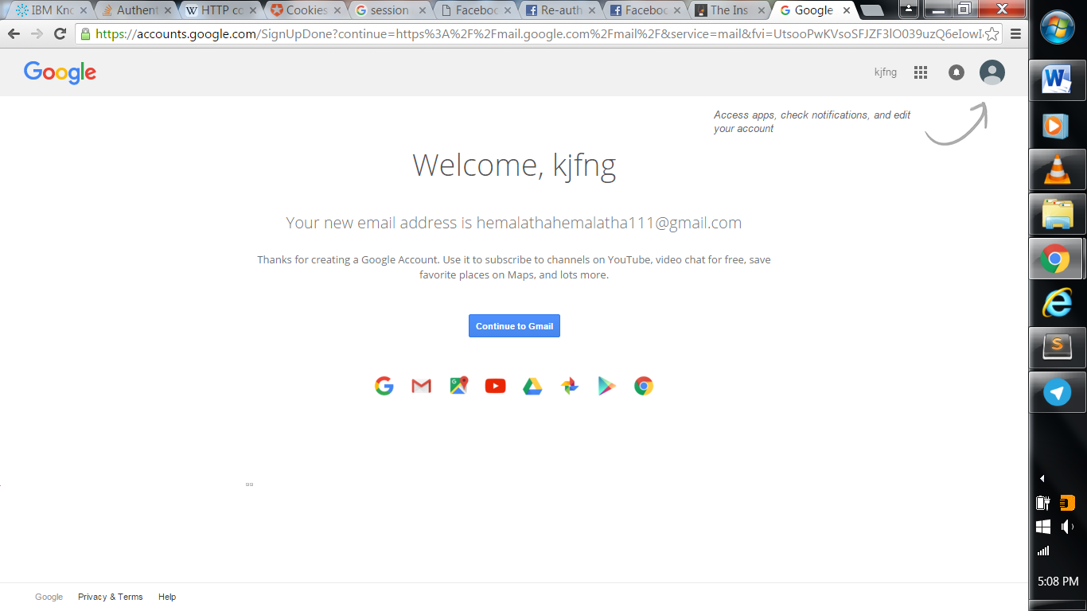

For Gmail account Automatically get into the account .For Example Facebook, Twitter, etc.. The second page show some security authentication will be asked. So we have to fill some requirements and get in to the main page.

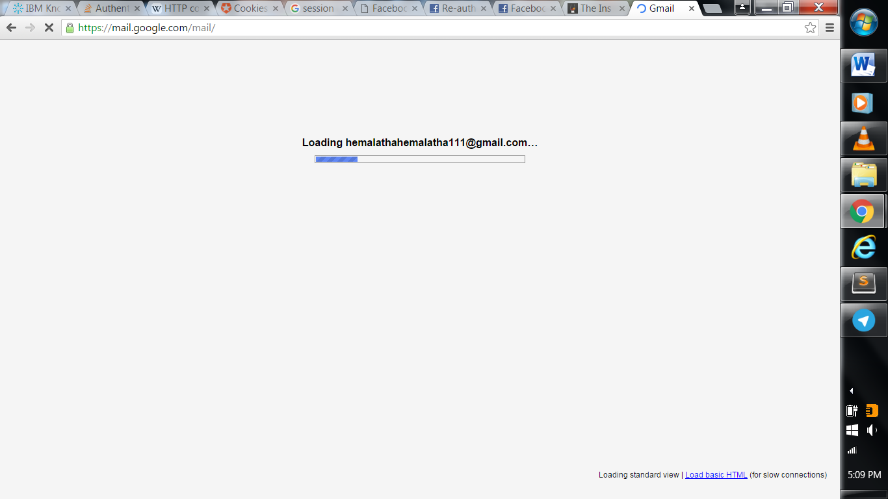

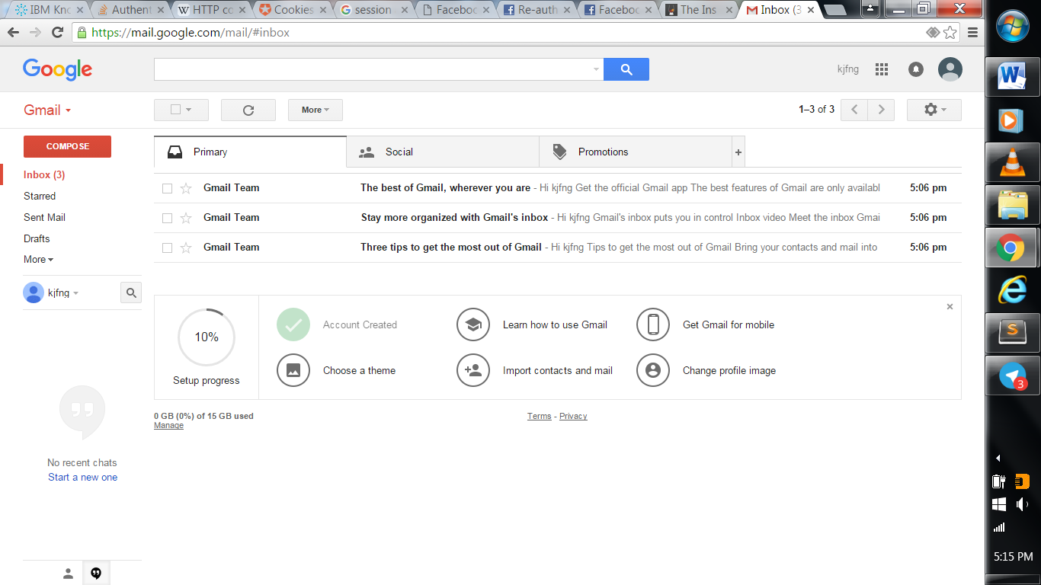

This is the one method to verify the Gmail account .Through Phone

